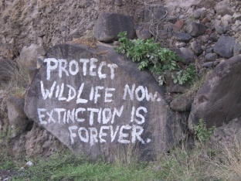
9 James Lane, Goodwill, Tel: 1 767 440 3835
P O Box 456, ROSEAU, Website: www.eccea.org
Commonwealth of Dominica, East Caribbean.
24th January, 2011

Secretary of State Hillary Clinton
Department of State
2201 C StNW
WashingtonDC 20520
Tel: (202) 647-9572
Fax: (202) 647-1579
Email: colemancl@state.gov (Personal assistant)
Web site: http://state.gov/

Honorable Madam,
Greetings!

I wish to draw your attention to a disaster that is unfolding concerning the protection of Whales in the Southern Ocean Whale Sanctuary - a Sanctuary established in 1994 by overwhelming majority vote of the International Whaling Commission (IWC) with support of the United States of America.

It is with dismay that we have looked on while Japan has, for the 17th consecutive year, sent its whaling fleet to the Southern Ocean Whale Sanctuary in defiance of this landmark international decision. But what is more frightening is that this year it has also included armed coast guard personnel in response to unarmed, nonviolent activists who are seeking to uphold the international decision which protects this Sanctuary.

In dispatching its armed coast guards Japan has not stated its intentions. However, the fact remains that it has deployed the capability to forcibly board or disable the activists' ship with threat of deadly force in support of an enterprise that is conducted in outright defiance of the spirit of this important international conservation decision.

If these coast guards use their arms this would constitute armed aggression at sea against unarmed citizens, some of whom are Americans. Environmentalists the world over are observing these developments and wondering where is the justice?

It has just been brought to our attention that among the myriad of people who object to Japans whaling in the Southern Ocean Sanctuary, a Californian man did a 25 day fast to draw attention to this issue, and he had the following to say, " ...If necessary I will join the countless individuals who have given their lives for two fundamental principles:
* The rule of law must prevail, and
* Armed aggression on the high seas is unacceptable ...."

We therefore beg of you, Dear Secretary of State, to use your good offices to intervene in this matter for the purpose of ensuring that no lives or limbs are lost at sea in this manner, and to restore the trust that people have had in international treaties.
Sincerely
East Caribbean Coalition for Environmental Awareness

Mona George-Dill,
President,
East Caribbean Coalition for Environmental Awareness,
Email: monageorge@cwdom.dm
Cell: 1 767 277 1377

